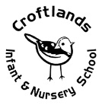
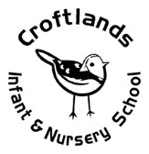
What I should already know?
People who live in my house.
How to role play in a house.
Who is a friend.
Knowledge
Knowledge Organiser
Reception – All about me

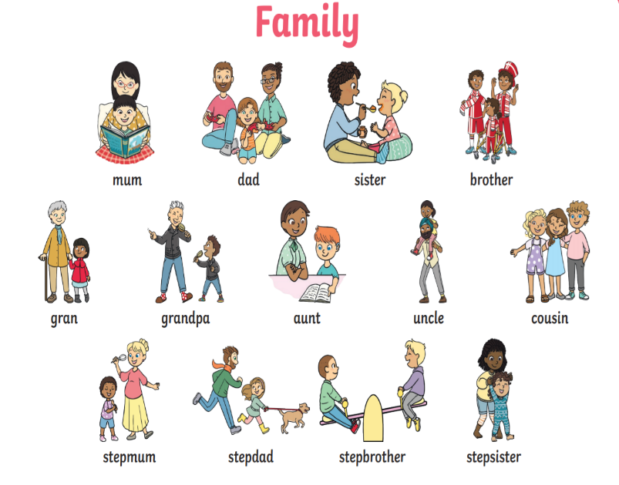
“When I was a baby..”
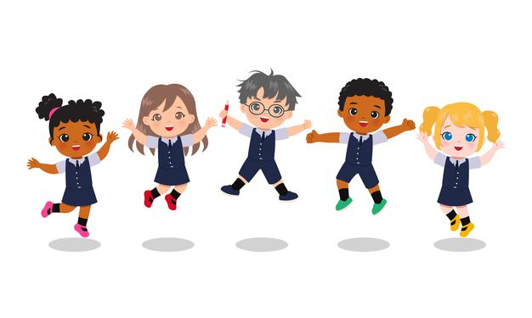
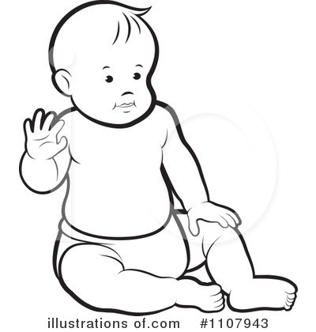
Key Questions
Can you name the members of your family? Can you talk about the things you like to do as a family?
What special events have you shared together as a family?
What do you want to be when you grow up?
What do we have in common with each other?
Why is it important to keep active and eat healthy?

“Now that I am older I can…”
What I will know by the end of this unit?
Be able to identify some parts of their body.
Know the effects exercise has on their bodies.
Have some understanding of growth and change.
Fruit and vegetables are healthy and we need to try and eat 5 portions a day.
Eye colours are blue, brown or green (or somewhere inbetween!).

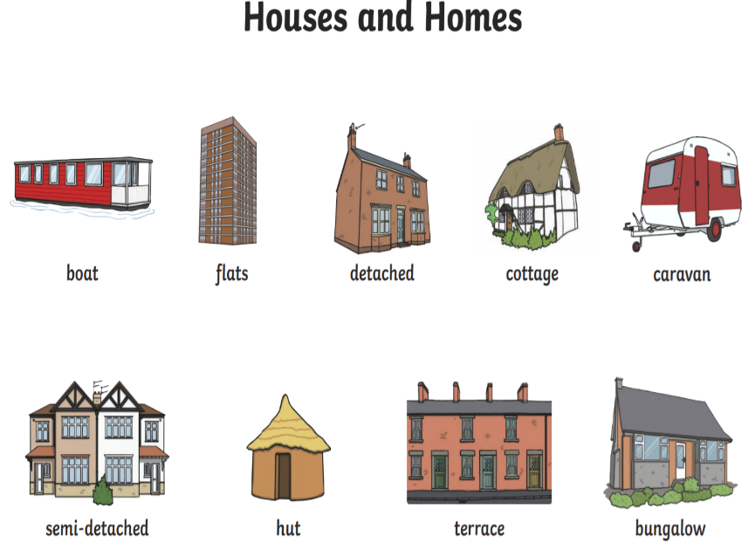
Books
In Year 1 children will:
There are many different humans and animals with different characteristics.
Humans have senses to help individuals survive.
Humans and animals need food to survive.
Humans and Animals need a variety of food to help them grow, repair their bodies, be active and stay healthy.

Possible Experiences

Vocabulary
Hair, head, ears, eyebrows, eyes, nose, mouth, chin
Baby, toddler, infant, exercise, pulse, heartbeat.
Songs and rhymes
Heads, shoulders, knees and toes
Days of the week
Months of the year
All by myself

Expressive Arts and Design
Self-portrait – using mirrors
Choosing correct eye colour & hair colour
Straw/cotton bud skeletons – teach glue skills
Lolly stick people puppets – teach lids on felt tips

Puppet show with skeletons – Funny Bones rhymes
Dancing to songs and moving to music
Using props to role play

Head, shoulders, knees and toes
The Skeleton Dance + More | Dance Songs for Kids |
Super Simple Songs
Body Parts Song
Dough disco – finger song
Personal, Social and Emotional Development
Learning about the school rules
Sharing and getting on with others -help in resolving conflict.
Friendships
similarities and differences between themselves and others
Enjoys a sense of belonging through being involved in daily tasks
Emotions- fears – likes, dislikes
Areas of Development
Reception – All about me

Physical development
• Runs with spatial awareness and negotiates space successfully, adjusting speed or direction to avoid obstacles • Can balance on one foot or in a squat momentarily, shifting body weight to improve stability • Can grasp and release with two hands to throw and catch a large ball, beanbag or an object • Creates lines and circles pivoting from the shoulder and elbow • Manipulates a range of tools and equipment in one hand, tools include paintbrushes, scissors, hairbrushes, toothbrush, scarves or ribbons
• Can tell adults when hungry, full up or tired or when they want to rest, sleep or play • Observes and can describe in words or actions the effects of physical activity on their bodies. • Can name and identify different parts of the body • Takes practical action to reduce risk, showing their understanding that equipment and tools can be used safely • Can wash and can dry hands effectively and understands why this is important • Willing to try a range of different textures and tastes and expresses a preference. Can name and identify different parts of the body • Observes and controls breath, able to take deep breaths, scrunching and releasing the breath • Can mirror the playful actions or movements of another adult or child • Working towards a consistent, daily pattern in relation to eating, toileting and sleeping routines and understands why this is important • Gains more bowel and bladder control and can attend to toileting needs most of the time themselves. • Dresses with help, e.g. puts arms into openfronted coat or shirt when held up, pulls up own trousers, and p

Understanding the world
mind – relax – yoga
• Shows interest in the lives of people who are familiar to them • Enjoys joining in with family customs and routines • Remembers and talks about significant events in their own experience • Recognises and describes special times or events for family or friends • Shows interest in different occupations and ways of life indoors and outdoors • Knows some of the things that make them unique, and can talk about some of the similarities and differences in relation to friends or family

• Comments and asks questions about aspects of their familiar world such as the place where they live or the natural world

